International Conference VIII Winter Methodological School
Invitation
February 16 and 17, 2023

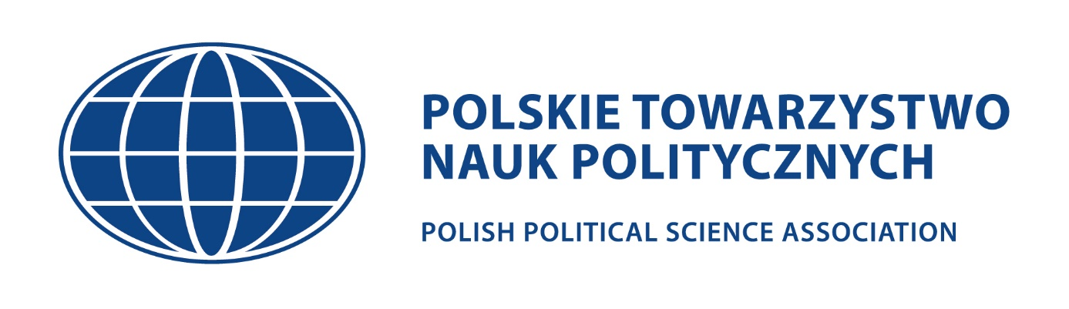
Section of Methods, Techniques and Research Tools
of the Polish of Political Sciences Association
and
Department of Philosophy and Political Theory
Faculty of Political Science and Security Studies
Nicolaus Copernicus University

Chairman of the Conference Scientific Committee
prof. dr hab. Roman Bäcker and dr hab. Krzysztof Kasianiuk

The Section of Methods, Techniques and Research Tools of the Polish Political Science Association (PPSA) and the Department of Philosophy and Political Theory of the Faculty of Political Science and Security Studies of the Nicolaus Copernicus University in Toruń are pleased to invite you to participate in the 8th Winter Methodological School, which will take place on February 16 and 17, 2023.
The event is addressed to scholars who would like to consult their research projects or current research in terms of methodological correctness among the most outstanding specialists in the country. The undertaking will consist of expert lectures on the methodology of social sciences and thematic workshop panels, during which the participants will present and submit their research ideas for discussion, and also learn how to properly prepare a grant application in competitions organized by the National Science Centre (NCN). Those interested will also be able to have individual consultations with invited specialists.
We direct our invitation to representatives of political science, international relations, security sciences, media studies and related disciplines. It will be possible to consult your research projects presented as part of NCN grants, doctoral dissertations, postdoctoral dissertations and any other research work.
The second day of the 8th Winter Methodological School will be devoted to developing ideas for team research projects. Participants will collaborate in groups by using their knowledge and competences to develop common research problems and approaches. Each group will strive to prepare a research concept that participants will be able to use while carrying out joint research. Participants will be classified into groups on the basis of content-related and methodological criteria.

Applications should be sent by December 15, 2022 to the address of the secretary of the conference: maria-lewandowska@o2.pl with the research project containing the methodological assumptions (template available at the end of the invitation).
The conference will be held in hybrid or on-line. It depends on the number of applicants and the epidemic situation in Poland.

Fee for participation in the conference (on-line):
50 PLN for members of PPSA, 100 PLN for others participants
Fee for participation in the conference (hybrid):
250 PLN for members of PPSA, 300 PLN for others participants*
*The fee doesn’t include accommodation

Fees should be paid to the following account:
Polskie Towarzystwo Nauk Politycznych (Polish Political Science Association)
ul. Krakowskie Przedmieście 3
00-927 Warszawa
bank account: 60 1020 1156 0000 7102 0064 8402
note on the transfer: VIII Winter School

The application form (in .doc, .docx or .pdf format) must contain the following elements:

Technical part:

First name and last name:
Title / academic degree:
Scientific affiliation:
Title of the project:
Phone number:
E-mail adress:
Address for correspondence:
Invoice data (if needed):

Substantive part:

Research topic:
Research goal:
Research field (substantive, temporal and territorial scope):
Outline of the state of research on the issue of interests and preliminary critique of the latest literature on the subject:
Theoretical approach:
Research problems and hypotheses (main and detailed):
Selection of sources:
Research methods and techniques with justification for choice:
Research tool (s):

